**Year 2 Semester 1 (2025)**

IT2120 - Probability and Statistics Lab Sheet 10



**FacultyofComputing**

# Exercise

**Instructions**: Create a folder in your desktop with your registration number (Eg: ”IT.......”). You need to save the R script file and take screenshots of the command prompt with answers and save it in a word document inside the folder. Save both R script file and word document with your registration number (Eg: ”IT........”). After you finish the exercise, zip the folder and upload the zip file to the submission link.

1. A vending machine owner claims that customers choose the four snack types (A, B, C, D) with equal probability. To test this claim, a researcher records the number of purchases for each snack type during one week and results are given below.

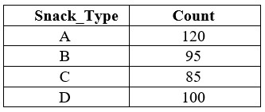

1. State the null and alternative hypotheses for the test.

1. Perform a suitable chi-squared test to test the null hypothesis.

1. Give your conclusions based on the results.

